

**A PROJECT REPORT**

**ON**

**ONE YEAR LIFE EXPECTANCY POST**

**THORACIC SURGERY USING**

**IBM WATSON**

**SUPERVISED BY**

Mr. Pradeepti Duggaraju

**SUBMITTED BY**

**Name of Student Project ID**

Potharla Pavan SPS_PRO_304

**INTRODUCTION**

1. Overview
2. Purpose

**LITERATURE SURVEY**

1. Existing Problem
2. Proposed Solution

**THEORITICAL ANALYSIS**

1. Block Diagram
2. Hardware/Software designing

**EXPERIMENTAL INVESTIGATIONS**

**FLOWCHART**

**RESULT**

**ADVANTAGES AND DISADVANTAGES**

**APPLICATIONS**

**CONCLUSION**

**FUTURE SCOPE**

**BIBILOGRAPHY**

**APPENDIX**

**INTRODUCTION**

1. **Overview**

The project “ONE YEAR LIFE EXPECTANCY POST THORACI SURGERY USING IBM WATSON” is Monitoring health outcomes is essential to enhance quality initiatives, healthcare management and consumer education. Thoracic Surgery is the data collected for patients who underwent major lung resections for primary lung cancer. The application of machine learning techniques for predicting post-operative life expectancy in the lung cancer patients is an area with little research and few concrete recommendations. In order to use machine learning techniques effectively, attribute ranking and selection is an integral component to successful health outcome prediction.

1. **Purpose**

This project is to have knowledge of peri-operative and post-operative mortality (life expectancy) and morbidity (health complications) of the patients who undergone a lung cancer surgery and to identify factors associated with an adverse outcome. It is to know about the health condition of a patient after going through the lung cancer surgery whether the person can survive after an year.

**LITERATIVE SURGERY**

1. **Existing problem**

Lung cancer is the most common form of cancer world-wide, and the most common cause of cancer death. Radical surgical resection, with or without adjuvant treatment, is still a Prerequisite for cure. In spite of different additional modes of treatment, survival is still poor. It is important to have knowledge of pre- and postoperative mortality (life expectancy) and morbidity (health complications), and also of risk factors prior to surgery, to be able to improve the quality of operative procedures and identify patients running the highest risk. This helps to optimize the patient’s condition, medication and respiratory status before surgery. Furthermore, the operative risks must be considered in relation to the long-term results in order to identify patients who will clearly benefit from surgery.

1. **Proposed Solution**

The IBM Watson Auto AI Machine Learning Service is developed to predict the post operative life expectancy of lung cancer patients using the computational methods. These methods were used specifically to predict whether a lung cancer patient will survive one year after he or she has had thoracic surgery. The results of each of the techniques were then measured and compared based on accuracy and performance. The model is deployed on IBM cloud to get scoring end point which can be used as API in mobile app or web app building

**THEORITICAL ANALYSIS**

1. **Block Diagram**

Deploy the model in Watson Studio

Patient will not Survive

Test the model in Watson Studio

Patient will Survive

Input the required attribute

1. **Hardware / Software designing**

**Hardware Configuration**

The Hardware used for the development of project is

1. Processor INTEL I5 10th GEN
2. RAM : 4GB
3. Harddisk : 1TB

**Software Configuration**

The Software used for the development of the project is

1. Operating System : WINDOWS-10
2. Python
3. Python for Data Analysis
4. Machine Learning
5. IBM cloud
6. IBM Watson

**EXPERIMENTAL INVESTIGATIONS**

To perform this experiment I have taken a dataset in which it consists of data of the patients who underwent major Lung Cancer Surgery. The dataset consist of columns as shown in the figure below

| **Attribute** | **Description** |
| --- | --- |
| **Diagnosis** | ICD-10 codes for primary and secondary as well multiple tumors if any |
| **FVC** | Air which is forcibly exhaled from the lungs after taking the deep breath |
| **FEV1** | Volume that is exhaled at the end of the first second of forced expiration |
| **Performance** | Performance status on Zubrod scale, Good (0) to Poor (2) |
| **Pain** | Pain before surgery (T = 1, F = 0) |
| **Haemoptysis** | Coughing up blood, before surgery (T = 1, F = 0) |
| **Dyspnoea** | Difficulty or labored breathing, before surgery (T = 1, F = 0) |
| **Cough** | Symptoms of Coughing, before surgery (T = 1, F = 0) |
| **Weakness** | Weakness, before surgery (T = 1, F = 0) |
| **Tumor_Size** | T in clinical TNM - size of the original tumor, 1 (smallest) to 4 (largest) |
| **Diabetes_Mellitus** | Type 2 diabetes mellitus (T = 1, F = 0) |
| **MI_6mo** | Myocardial infarction (Heart Attack), up to 6 months prior(T = 1, F = 0) |
| **PAD** | Peripheral arterial diseases (T = 1, F = 0) |
| **Smoking** | Patient smoked (T = 1, F = 0) |
| **Asthma** | Patient has asthma (T = 1, F = 0) |
| **Age** | Age at surgery |
| **Death_1yr** | 1 year survival period - (T) value if died (T = 1, F = 0) |

Also created an IBM cloud account and inserted dataset for creating a Watson Machine Learning service. Further created as Machine Learning Instance. Then deployed the model and tested the model by giving some necessary inputs and predicted the required output

Also created a Nod-RED web application service and installed Dashboard Nodes for the model to be deployed. Imported the .json file form the navigation key and made some necessary corrections in the function nodes and http:request node to the model to be deployed successfully

**FLOWCHART**

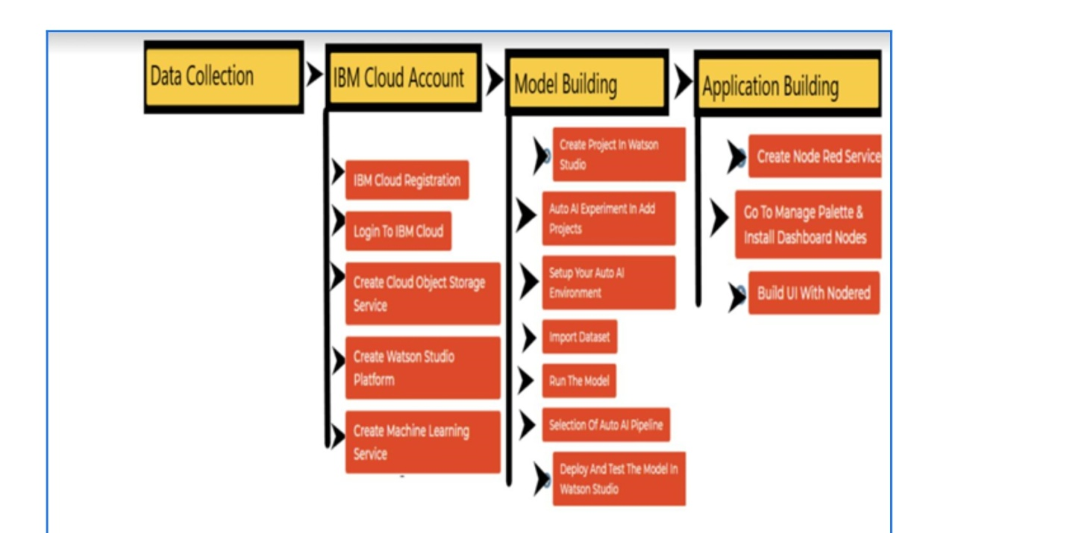

**RESULT**

Output in Watson Studio 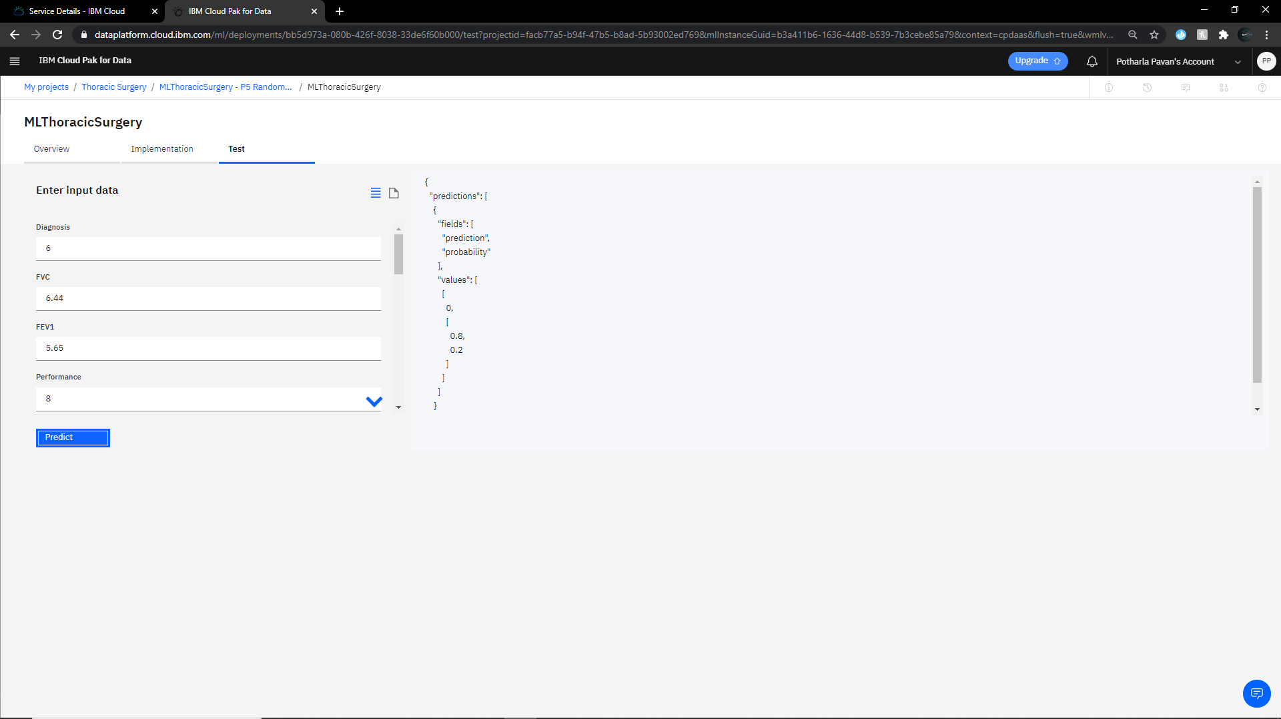

Output in Nod-Red application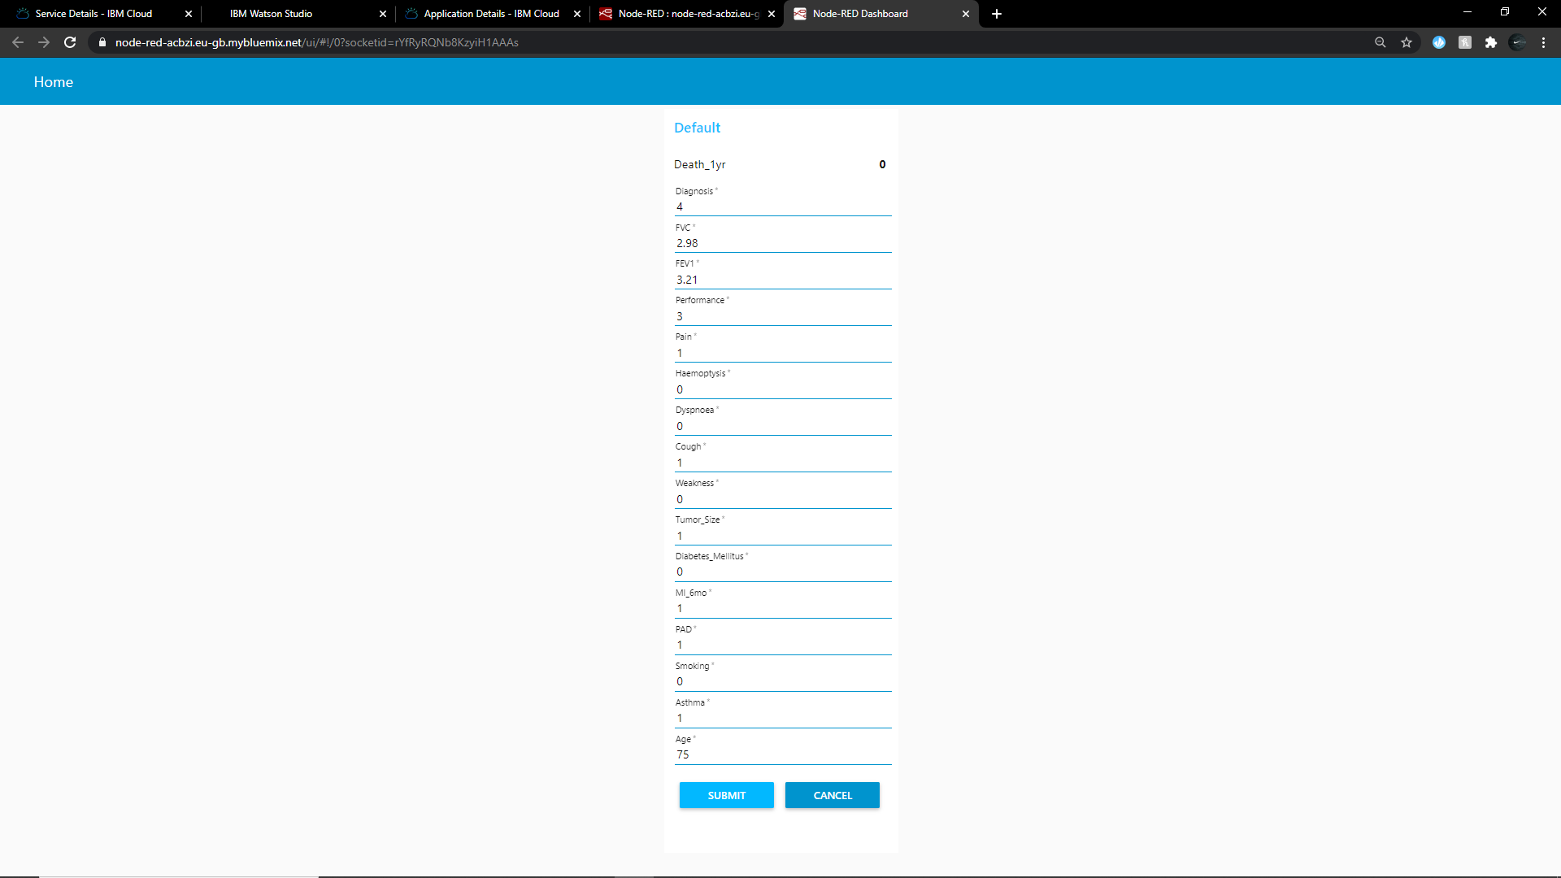

**ADVANTAGES AND DISADVANTAGES**

ADVANTAGES

1. Prediction speed is high
2. Server side is authenticated
3. Handle complex data
4. Effective

DISADVANTAGES

1. Data Acquisition Interpretation of results High error susceptibility
2. Prediction on missing feature can be inaccurate

**APPLICATIONS**

These methods were used specifically to predict whether a lung cancer patient will survive one year after he or she has had thoracic surgery. The results of each of the techniques were then measured and compared based on accuracy and performance. The model is deployed on IBM cloud to get scoring end point which can be used as API in mobile app or web app building. We are developing a web application which is built using node red service. We make use of the scoring end point to give user input values to the deployed model. The model prediction is then showcased on User Interface.

6 Conclusion

**CONCLUSION**

In this study, the quality of the attribute ranking and selection methods has been evaluated to improve the prediction for life expectancy of lung cancer patients after thoracic surgery. The results show that boosting is not always the better choice where attribute ranking and selection can perform better in improving prediction accuracy. Other attribute selection and machine learning techniques can be introduced in the future work to gain a better prediction model performance of the dataset

**FURTURE SCOPE**

As of now usage Machine Learning is less, further it can be implemented to a higher extent by providing more data to the model. The disadvantages can be disolved, advantages for the project will be increased. Reusability is possible as when required in the application. There is flexibility in all over the module

**BIBILOGRAPHY**

The content in this project report is taken from the following sources:

* <http://smartbridge.teachable.com>
* <http://cloud.ibm.com>